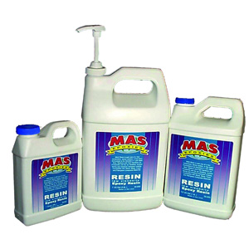
FLAG Resin
Thicker formula resists sagging in vertical applications
MAS Epoxies FLAG Epoxy Resin is a medium body resin designed to perform as an adhesive and structural laminating foundation. Applications include filleting, fairing, laminating, gluing, barrier coating and cold molding. The medium viscosity allows for an easy incorporation of fillers when fairing putties, gluing slurries and filleting compounds are required. FLAG is more reactive than MAS Low Viscosity Resin when mixed with Medium Hardener, which keeps fillets and fairing from slumping. FLAG Resin is next day sandable when cured with Medium Hardener at temperatures above 60°F. FLAG Resin may be used with all MAS Hardeners. FLAG/Medium is our top recommendation for filled applications.
TEMPERATURE |  | RESIN / SLOW |  |  | RESIN / MEDIUM |  |  | RESIN / FAST
Fahrenheit | Celcius | Pot Life | Thin Film Set | Full Cure | Pot Life | Thin Film Set | Full Cure | Pot Life | Thin Film Set | Full Cure | Tack Time | Cure Time
140°F | 60°C | 1.5 m | 28 m | 11:15 h | 1.22 m | 16 m | 7:52 h | 39 s | 11.5 m | 4.5 h
131°F | 55°C | 2.25.m | 42 m | 16:52 h | 1.83 m | 24 m | 11:34 h | 58 s | 17.25 m | 6.45 h
122°F | 50°C | 3.0 m | 56 m | 22.5 h | 2.44 m | 32 m | 15:45 h | 1.3 m | 23 m | 9 h
113°F | 45°C | 5.75 m | 1:15 h | 30 h | 3.32m | 45 m | 21 h | 1.75 m | 30 m | 12 h
104°F | 40°C | 8.6 m | 1:52 h | 45 h | 4.88 m | 67 m | 31:30 h | 2.63 m | 45 m | 18 h
95°F | 35°C | 11.5 m | 2:30 h | 2.5 d | 6.5 m | 1:30 h | 42 h | 3.5 m | 1 h | 1 d
86°F | 30°C | 17.25m | 3:45 h | 3.75 d | 9.75 m | 2:35 h | 63 h | 5.3 m | 1:30 h | 1.5 d
77°F | 25°C | 23 m | 5 h | 5 d | 13 m | 3 h | 3.5 d | 7 m | 2 h | 2 d
68°F | 20°C | 34.5 m | 7.5 h | 7.5 d | 19.5 m | 4.5 h | 5.25 d | 10.5 m | 3 h | 3 d | 10-12 m | 4 hours
59°F | 15°C | 46 m | 10 h | 10 d | 26 m | 6 h | 7 d | 14 m | 4 h | 4 d |  |  | same as FAST
50°F | 10°C | 69 m | 15 h | 15 d | 39 m | 9 h | 10.5 d | 21 m | 5 h | 6 d
41°F | 5°C | 92 m | 20 h | 20 d | 52 m | 12 h | 14 d | 28 m | 6 h | 8 d
* NOT RECOMMENDED |  |  | s= seconds; m=minutes; h=hours; d=days

Both Resins are designed to be mixed with one of the MAS Hardeners in a
2:1 Ratio, 2 parts Resin: 1 part Hardener. Never change the ratios.
Resins are compatible with each other for custom mixing.
MAS Adhesives Cure Schedule
Applies to LV and FLAG Resin when mixed with Slow, Medium or Fast Hardeners
Low Viscosity Resin
Ideal for wetting through fiberglass and structural fabrics (sheathing),
clear coating, saturation coating, vacuum bagging, infusion and sealing wood.
Mix with any MAS Epoxies Hardener in a 2:1 Resin to Hardener ratio*. It can be cured in a wide temperature range forming high strength solids with excellent moisture resistance in a wide variety of applications.
Add MAS Fillers to use the epoxy as a filling and fairing compound to bridge gaps and/or fill voids, gouges, and scratches. It’s thin enough to allow for excellent thin-film flow and self-leveling characteristics, providing for complete wetting out of fiber-reinforcing fabrics and reducing the potential for voids and other imperfections. Made from 100% solids, there are no solvents. Shrinkage is less than 1%. (*Infusion Resin and Infusion Hardeners are mixed 3:1)
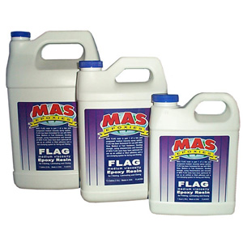

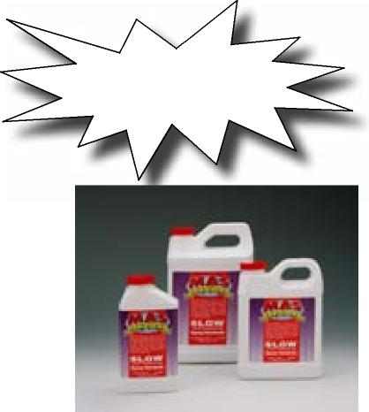
Order Our
Pre-Calibrated Pump Set for Quick, Accurate Mixing.
Page10
MASEPOXIES.COM 3
MAS Hardeners are Non-Blushing
- Good Ultraviolet Stability • Smooth Finishes
- Cures in High Humidity • Post Curable
- Superior Secondary Bond Strength
- Custom Blend for Your Unique Conditions
Slow Hardener 30 minute pot life • 4 hour working time at 70°F
MAS Slow Hardener, when used with MAS Epoxy Resin, provides an
extended gel time for controlled working and cure times. A mix of MAS
Low Viscosity Resin and Slow Hardener is highly recommended for:
- Large surface coating or laminating
- Fast wet-out of reinforcing fabrics
Formulations cure blush-free and eliminate the need for time consuming
wash downs during on-going laminations or repetitive build coats.

Medium Hardener 15 minute pot life • 3 hour working time at 70°F

MAS Medium Hardener has a moderate pot life. Gel and thin set times provide advantages when filleting and fairing. When mixed with MAS Fillers, the epoxy gels and sets quickly enough to avoid draining and sagging, while still allowing ample open working. Medium Hardener is highly recommended for:
- Filleting and Fairing
- When overnight sandability is more important than continuous laminating and open time
Medium Hardener also provides a beautifully smooth, void free finish with great resistance to
milking out during application and fogging in critical clear coating applications.
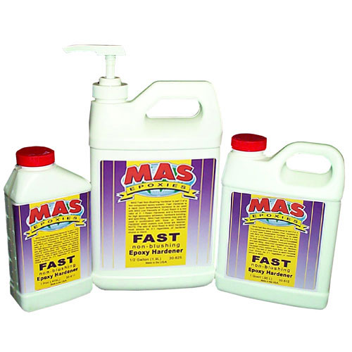
Fast Hardener 10 minute pot life • 2 hour working time at 70°F
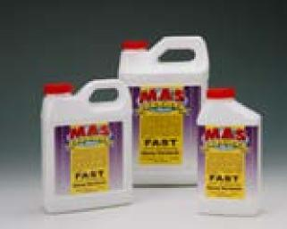
MAS Fast Hardener is our quickest ambient temperature hardener and can be used with either the Low Viscosity or FLAG Resin. FAST Hardener can also be used as an accelerator with Slow or Medium Hardener when customized cure times are required. Use FAST Hardener for:
- Hardware Bonding, Spot Filling and Fairing
- High strength secondary bonding applications such as structural labbing and repair laminations
- Fast wet-out of heavy reinforcing fabrics
- As an accelerator for Infusion applications
Fast Hardener allows for overnight curing in low temperature conditions.

Applications:
Wet-Out of Reinforcing Fabrics, Laminating, Hardware Bonding, Spot Filling,
Fairing, Structural Tabbing. Custom blend as needed. Mix hardeners then add the resins.
They say a picture’s worth a thousand words!
Just watch our on-line videos.
- Intro to Epoxy • Filleting and Fairing • Clear Coating
- How to Repair: Soft Deck, Stringers, Transom, Flooring
and the “Famous” Cotton Ball Trick!

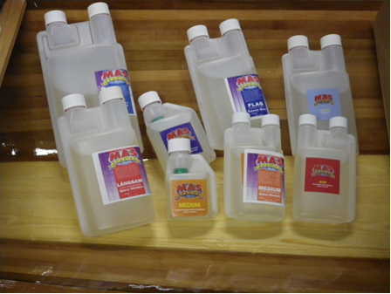
Handy Repair Kits
A kit contains of 3 parts (that makes it 2:1)
1 Flag viskos. 1 Low visko epoxy and
1 Hardener (mostly used is medium)

We have 0,6 and 3 l and you choose hardener
accordingly to the task.

.

Fillers

Act as thickening agents when mixed with epoxy
Use for enhanced strength, structural bonding, filling and filletin.g
MAS offers a variety of fillers to meet the specific needs of different applications.

Cell-O-Fill Non toxic, non-carcinogenic. For use in place of Colloidal Silica when high strength and low density are required. Application: bonding, filling and filleting
Phenolic Micro Balloons When low density, light weight, sandable, paint ready surfaces are required. Application: fairing and filling
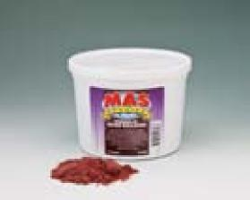
Colloidal Silica When a hard solid with high density is needed. Application: structural bonding, filling and filleting
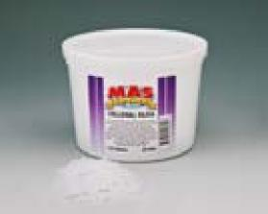
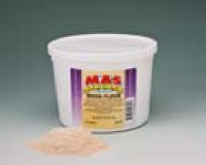
Wood Flour When a hard solid for filling and filleting is needed. Application: wood gluing, filleting and bonding
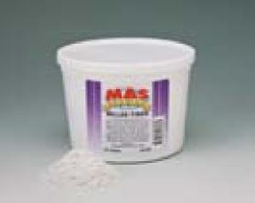
Milled Fibers (1/32” milled fiberglass)Provides extremely high strength.

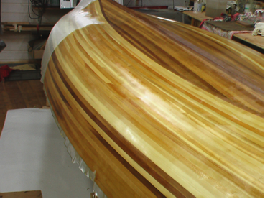

Pågående laminering!

Application Recommendations
Recommended Product | Activity
Any of our Resin and Hardener mixes or Super Epoxy-All may be used. Add Colloidal Silica, Cell-O-Fill or Wood Flour to thicken mix,and then apply. (Blend resin and Hardener BEFORE adding filler). | Bonding Porous Woods
Pre-Coat pieces, to be bonded, with a mixture of FLAG Resin/ Medium Hardener. Add Colloidal Silica or Cell-O-Fill to the remaining mixture until it is the consistency of wet pudding, and then apply this Colloidal Silica filled mixture pre-coated surface. Clamp for 24 hours at 75°; 48 hours at 50°F . Super Epoxy-All may also be used. | Bonding Dense Woods
Pre-Coat with FLAG Resin/Medium Hardener mixture. Rub mix into clean surface with Scotch brite pad. Add Colloidal Silica to thicken mix if needed. | Bonding Iron and Steel
Pre-clean and treat with acid etching agent. Convert with a neutralizer (Bond like Dense Wood) these products are available through Marine and Auto Body Supply stores. Flexbond 5000 has been used for Aluminum window frames. | Bonding Aluminum
FLAG Resin and Medium Hardener with microballons to thicken fairing compound formula . Super Epoxy-All may also be used. | Bonding Foam and Core
Slow hardener with Low Viscosity Resin or FLAG - dilute first coat with 2% lacquer thinner or denatured ^{alco-}Clear hol. Squeegee into surface. Remove excess. For 2nd and 3rd coat use Flag and Medium. | Coating Wood
MAS Resin (Flag)/Fast Hardener or Medium Hardener mixtures are good for deck beams, stringers, etc. Cell-O-Fill or Colloidal Silica to thicken. Super Epoxy-All may also be used. | Laminating Wood Structures
For Wood - FLAG Resin/ Medium speed hardener thickened with 1 part Colloidal Silica and 2 parts Wood Flour until looking just dry. Tip: For a clean fillet, try using the back of a spoon or a piece of PVC pipe.  For Fiberglass - Same as Wood, except substitute Milled Fibers or Colloidal Silica for Wood Flour. Super Epoxy-All may be used for wood and fiberglass applications. | Filleting (Structural)
FLAG Resin/ Medium speed hardener thickened with 1 part Colloidal Silica and 2 parts Phenolic Micro Balloons to make a smooth “peanut butter”. | Filleting/Fairing (Cosmetic)
MAS Low Viscosity Resin or Flag Resin mixed with Medium or Slow Hardeners. Use Slow, Medium or Fast for “No Blush” and next day green stage. The surface will be ready for recoat which requiring a light sanding to prep. To use for Wood Saturation and Rot Prevention, add 2% lacquer thinner to Low Vis Resin and Hardener mix. MAS Resin, or FLAG Resin and Slow or Medium Hardener. 4-7 coats. | Laminating Fiberglass
Use for Wood Saturation and rot Prevention. add 2% lacquer thinner to Low Vis Resin and Hardener mix. | Penetrating Epoxy
MAS Resin, or FLAG Resin and Slow or Medium Hardener. 4-7 coats. (Optimal min. temperature while curing 70°F). Keep surface dry while curing. Allow full cure before launching boat  (See cure schedule). | Osmotic Barrier
MAS Low Viscosity Resin and InfuCure Ambient or InfuCure High Temperature Infusion Hardener. | Infusion Vacuum Bagging
Flexbond 5000 or Super Epoxy-All can be used Above and Below the water line. | Thru Hole Fittings
.

When in doubt, use FLAG Resin and Medium Hardener. It will cover 90% of most epoxy projects. Don’t forget One Gallon of Resin needs a Half Gallon of Hardener

Epoxy Frequently Asked Questions

Please note that you can find lots of additional information, in-depth information and ‘How To’ videos at masepoxies.com.
What is the Mix Ratio for MAS Epoxies?
MAS has simplified the process for using and mixing our basic epoxies by creating a highly flexible system of two resins and three hardeners. The mix ratio is 2:1 Resin to Hardener. That ratio stays the same when the hardeners are custom blended. When blending hardeners, blend in separate containers from the resin, then mix with the resin. Be sure to maintain the 2:1 ratio, resin: hardener.
Please note that larger quantities will harden faster and smaller quantities will harden more slowly. We also offer specialized epox-ies including the MAS INFURES system and Rapid Cure fast hardening epoxy for quick fixes that require different mix ratios.
How much mixing is required?
Mixing is the key to a thorough cure, good films and strong bonds. One and a half to two minutes of aggressive mixing, swiping the sides and bottom is recommended. Be sure mix ratio is two parts resin to one part hardener (2: 1). Use clean plastic or uncoated paper cups or buckets and a clean mix stick. We also recommend taking the mixed batch and putting it into a clean container, scraping the sides and bottom and then mix again. This assures a complete mix.
What is the recoat time?
Since epoxies from MAS are 100% solid (no solvents), recoat time can be as short as it takes to achieve surface tack. If more than 12 hours passes between coats, do a light scuff sand. Use a cotton ball to test if a light scuff sand is needed. If the epoxy holds the hair of the cotton ball, you can recoat without sanding. If it doesn’t, a light scuff sand will help adhesion between coats.
Can I speed up the mix by adding more Hardener?
ABSOLUTELY NOT! Adding more hardener throws off the ratio and you will end up with a gooey mess that never cures.
How does temperature variation affect epoxy?
For clear coating, we like to see the resin remain over 55 to 60°F. For bonding, anything over 45°F is adequate.
For every 18°F, the temperature falls below 77°F, the pot life will double for the mix. The thin film set will come close to a 1.3 increase in time. The exact opposite will occur as temperatures increase above 77°F. Applications which are allowed to cool below the freezing point must be warmed to achieve a full through Cure. In the case of freezing, the solid or film must be checked for hardness to insure full strength has been achieved.
What surface preparation is needed prior to application of epoxy?
All surfaces should be cleaned of any contaminates, such as oil, grease and pooled water. Bio-Solv is great for surface clean-up. Light sanding is recommended. A clean cloth moistened with Bio-Solv isopropyl alcohol or plain water may be used to clean surfaces and to remove dust. DO NOT USE ACETONE or a TACK CLOTH to clean the surface.
What tools are used to apply the epoxy?
For coating and fiberglass, a short nap 1/8” nylon bristle roller, plastic squeegee, or disposable brushes. For bonding, a glue brush or a squeegee with notches cut into the edge.
Tips and techniques for filler use and selection (filleting and fairing)?
It is no longer necessary to have many different resin systems around for laminating, filling, filleting, fairing and adhesive bonding. One simple MAS Resin and two hardeners, MAS Slow and MAS Fast, will provide you all the flexibility required to make different thickened putties for standard build and repair operations. Please see the Application Recommendations chart at the front of the catalogue and visit masepoxies.com for more information.
How to protect the epoxy?
Epoxy surfaces should be protected from sun exposure. Clear coats may be protected by a good quality varnish or urethane with UVA protection additives. Paint is always considered a 100% filter. Indoor pieces do not need varnish over epoxy.
10. Can a stain be used on the project?
To use a stain on an epoxy project, use a waterbased stain under the epoxy clear coat. Be sure stain is fully dry before coating work with epoxy. Always test first using the cross hatch test: Apply the stain on a scrap piece of wood. Let it dry. Apply the epoxy over the stain and let it sit overnight. Next day cut a tic-tac-toe image into the epoxy with a shop knife. Place a piece of Duct tape on each of the nine squares. Try to remove the epoxy. If it come off easily without any wood chards then there is an adhesion problem and will not work, but if it comes off with bits of wood attached the epoxy is penetrating the stain and will adhere well.

11. How do I clean up?
Gloves and other personal protection should always be used. If you should get any epoxy on your skin, it should be cleaned off with a waterless soap immediately, then thoroughly washed with soap and water. Tools can be washed with Bio-Solv, white vinegar or isopropyl alcohol. Semi-gelled epoxy can be removed with Bio-Solv.
12. What protection is needed when using epoxy?
Disposable gloves should always be used and eye protection is important if any splashing may occur. A respiratory mask (like 3-M Easy Air) should be used. Epoxy may cause irritation of the skin, especially fair skin.
Avoid all direct skin contact with resin, hardeners and mixed epoxy by wearing gloves and other clothing. Clean any uncured epoxy off the skin with waterless soap immediately after contact. NEVER use solvents to remove epoxy from the skin. Always wash thoroughly with soap and water immediately after contact.
Protect your eyes by wearing protective eye wear. If contact should occur, flush eyes immediately with running water for 15 minutes. If discomfort continues, seek medical attention.
Avoid breathing vapors. Use epoxy only in areas with good ventilation. In small areas, always have a supply of fresh air and exhaust any fumes. Wear a respirator with an organic vapor cartridge. Wear a dust mask when you sand the epoxy. If it has cured for less than a week, use a respirator with the organic vapor cartridge in combination with a dust pre-filter.
Avoid ingestion. Wash thoroughly after each use and especially before eating or drinking.
Clean up spills with a squeegee and paper towels. Scrape up as much material as possible with the squeegee before using the paper towels. Sand, clay or other materials may be used to contain or soak up a spill. Clean residue with Bio-Solv, white vinegar or isopropyl alcohol. Always wear protective gloves when cleaning up spills or at the end of a job.
Dispose of resin, hardener and empty containers safely. Do not dispose of resin or hardener in a liquid state. Before dispos-ing of resin and hardener containers, puncture the corners of can and drain residue into clean, sealable containers for re-use. Small quantities of resin and hardener can be mixed and cured completely to a non-hazardous solid. Place pots of curing resin and hardeners outside on the ground to avoid the danger of excessive heat and vapors. Dispose of after the reaction is com-plete and the mass has cooled. Then follow your local, state and federal regulations for proper disposal.
13. What are the major pitfalls that most users fall into?
When instructions and temperature adjustments are properly followed, projects go well. Some common problems include:
Bad mixing practices cause 99% of all problems. MIX, MIX, MIX and MIX some more.
During coating, the temperature falls below dewpoint. Even a small temperature decrease can cause changes in cure times and bonding. A little temperature goes a long way toward good coating.
Weak bond is a result of too much clamp pressure. The key to a strong bond is light pressure and adding the correct filler. Allow maximum clamp time and warming the piece can reduce this time (a light works well).

Glossary
BLISTERING
A phenomenon which occurs in boat hulls because the materials used to manufacture the hulls is water permeable (generally FRP). The laminate absorbs moisture which collects on the surface, intermediately or deep. Eventually, the pressure from this water buildup is high enough to form bulges in the surface.
B-STAGE
Intermediate stage of curing, not yet fully cured. Will not flow, but will yield to pressure.
COHESION
The state in which the particles of an adhesive are held together.
COMPOSITE
A combination of materials that result in an end product with characteristics superior to any one of the elements singly.
CORE MATERIALS
The central member of a sandwich construction. Normally low in density, light weight material used to separate structural skins. Typically weight is expressed in pounds per cubic foot.
CURE
The change from liquid to solid caused by chemical reaction of the components of an adhesive.
FIBER CONTENT
The amount of fiber present in a composite
FIBERGLASS
One of the oldest, strongest, and lowest cost reinforcement materials of all fibers today. The fibers are available in woven and non-woven forms.
FIBER REINFORCED PLASTIC (FRP):
A general term for a composite that is reinforced with cloth, mat, strands, or any other fiber form and resin.
FILLERS
Materials which are added to resins for special flow characteristics, to extend volume, or to add strength to the article being produced.
HAND LAY-UP
Refers to prewetting mixed resin using a brush, roller, or squeegee. The fabric product is placed over or into the resin-wet open mold surface and resin is again applied as necessary to achieve a totally wet laminate. Successive laminates and or core materials are added into a designed schedule.
LAMINATE
Product built up by bonding two or more layers of materials.
PRIMARY BONDING
Bonding situation where laminate is completed in one continuous cycle without total curing of intermediate plies.Primary bonding is advantageous over secondary bonds as interlaminar properties are enhanced when a chemical as well as a mechanical bond is present. Sometimes the part size, thickness or manufacturing sequence preclude a continuous lay-up, thus requiring the application of wet plies over a previously cured laminate, known as secondary bonding.
POST CURE
Heating solid during curing cycle to increase physical properties

POT LIFE
Amount of time between the mixing and gel stage in which an epoxy remains usable in the pot at 77°F. Pot Life for epoxies depends on temperature, shape of container, and hardener used. Pot Life is different from Working Time
PRINT THROUGH
Teleqraphing of the image of glass strands throuqh the gel coat film. A visual phenomena caused by low Tg temperatures when air in entrapped in the glass fibers.
SECONDARY BONDING
The joining of two or more already cured composite parts using adhesives. The only chemical or thermal reaction occurring is the curng of the adhesive itself
STRENGTH
The measure of the stress required to deform or break a material.
Tg/HDT (HEAT DEFLECTION TEMPERATURE)
The temperature at which a thermoset resin will begin to loose stiffness properties.
HDT - The temperature at which a material will begin to soften and deflect under load.
THERMOSETTING
A resin that polymerizes when subjected to heat. Epoxies are thermosetting.
THIN FILM SET
The surface becomes tack free. A thumb print will show on the surface, but no epoxy will come off onto your thumb (Please wear gloves!)
TOUGHNESS
A measure of the energy required to break a material.
VISCOSITY
Thickness of a liquid. Honey is very viscous, water is not. Expressed in cengpoise (cps). The viscosity of water is 1 cps. Higher numbers represent thicker material.
WET LAY-UP
This method is normally used for building fiberglass boats. Dry glass reinforcing mat, or cloth is laid out on the inside of the mold and covered with resin from a bucket or spray gun. A roller is then used to press the resin into the glass and to work out air bubbles.
WORKING TIME
Length of time during which a formula remains workable after it has been applied.

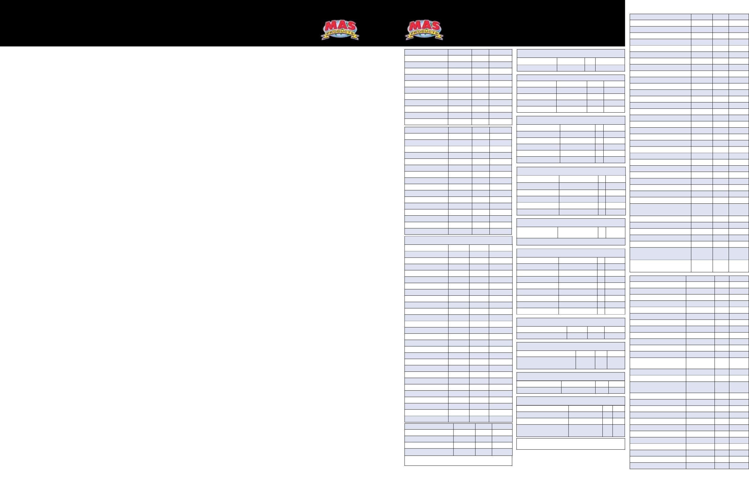

BÅTBYGGERIET
TUNARPS KVARN AB

A supplier for boat builders and other epoxyusers.
Welcome to the BÅT.AB!

BÅTBYGGERIET is a small family owned business that has existed since the spring of 2006. We are now expanding the business with introducing MAS Epoxies.

BÅTBYGGERIET have used MAS Epoxies for 6 years (15 boats since the start). And 50-60 kayaks have been built in various "workshops" with MAS epoxy kits and its increaseing. The fact that the epoxy is very easy to work with has helped us when building our hulls. They are characterized by the clear epoxy laminated hulls that preserve the sense of wood. Our high demands on the epoxy highlights the woodwork, it is seldom visible, that is satisfaction and I will be pleased! The boat has a permanent protection and is very strong. Now we want to share this very easy to use epoxy with more users!

Our business idea is to offer builders (professionals and amateurs) a material with the best features that makes epoxy work easier.

Our work:
• Sales and distribution of MAS EPOXY
products to resellers and end users.
• Contract work of small boats in epoxy
laminated carvel.
• Kits for home builders DIY with
introductory courses
• Strips to kayaks and rowboats and other
(contracts strips can be 8 - 15mm thick if
Desired, also in long lengths!
• Veneers in cedar up to 3.65m (12 ft)
lengths of 3.8 mm thick and 150-200mm
wide.

Why we chose MAS?
- With NO BLUSH / NO Wax is no need to wash or sand between uploads (VAX no stains, no Acetone example)
- Wets through the reinforcement fabric very well.
- Works well in low temp.
- Always a mixing ratio of 2:1
Hardeners and resins are compatible.

Uses for MAS Epoxies
Lamination with various reinforcing weaves, fiberglass, carbon fiber, aramidweave etc. , bonding metals. Fill in holes and damages, surface smoothing / filling. Glue frames mm. Customize epoxy mixture to your needs (cure time / viscosity).
MAS epoxy is used in a variety of areas other than the ones described here.

See our tutorial videos (English-speaking)
• Intro to Epoxy • Filleting and Fairing
• Clear Coating
• How to Repair: Soft Deck, Stringers, Transom, Flooring and the "Famous" Cotton Ball Trick!
Available at www.masepoxies.com

We hope you will like our Epoxy, it is not like others ” it´s simple perfection”

Björn Nilsson Thafvelin, Vd

BÅTBYGGERIET
TUNARPS KVARN AB

Products

Artikel nr | Artikelbeskrivning | Enhet | Vikt / enhet (Kg) | ÅF förpackning.
Part number / Watski no | Part Description | Unit | Weight /unit (Kg) | Qty in master box
660013 / 104934 | Low Vis Resin / Slow Hardener | 1.5 litre | 1,5 | 1
660020 / 104935 | Low Vis Resin / Slow Hardener | 3.0 litre | 3 | 6
660044 / 104936 | Low Vis Resin / Slow Hardener | 7.5 litre | 7,5 | 4
660099 / 104937 | Low Vis Resin / Medium Hardener | 1.5 litre | 1,5 | 6
660105 / 104938 | Low Vis Resin / Medium Hardener | 3.0 litre | 3 | 6
660129 /104939 | Low Vis Resin / Medium Hardener | 7.5 litre | 7,5 | 4
660174 / 104940 | Low Vis Resin / Fast Hardener | 1.5 litre | 1,5 | 6
660181 / 104941 | Low Vis Resin / Fast Hardener | 3.0 litre | 3 | 6
660198 / 104942 | Low Vis Resin / Fast Hardener | 7.5 litre | 7,5 | 4
660211 / 104943 | Flag (thick) Resin / Slow Hardener | 1.5 litre | 1,5 | 6
660228 / 104944 | Flag (thick) Resin / Slow Hardener | 3.0 litre | 3 | 6
660242 / 104945 | Flag (thick) Resin / Slow Hardener | 7.5 litre | 7,5 | 4
660297 / 104946 | Flag (thick) Resin / Medium Hardener | 1.5 litre | 1,5 | 6
660303 / 104947 | Flag (thick) Resin / Medium Hardener | 3.0 litre | 3 | 6
660327 / 104948 | Flag (thick) Resin / Medium Hardener | 7.5 litre | 7,5 | 4
660372 / 104949 | Flag (thick) Resin / Fast Hardener | 1.5 litre | 1,5 | 6
660389 / 104950 | Flag (thick) Resin / Fast Hardener | 3.0 litre | 3 | 6
660396 / 104951 | Flag (thick) Resin / Fast Hardener | 7.5 litre | 7,5 | 4
660402 / 104952 | Handy Kit Low Vis / Flag / Slow | 600 ml | 0,6 | 6
660419 / 104953 | Handy Kit Low Vis / Flag / Medium | 600 ml | 0,6 | 6
660426 / 104954 | Handy Kit Low Vis / Flag / Fast | 600 ml | 0,6 | 6
660877 / 104955 | Handy Kit (large) Low Vis / Flag / Slow | 3.0 litre | 3 | 6
660884 / 104956 | Handy Kit (large) Low Vis / Flag / Medium | 3.0 litre | 3 | 6
660891 / 104957 | Handy Kit (large) Low Vis / Flag / Fast | 3.0 litre | 3 | 6
test produkt | BIO SOLV | 0,5litre | 0,6 | 10
H312050 / 104958 | Laminating brush (3 pack) |  |  | 10
H1200 / 104959 | Plastic Spreader 100x125 , 150 ( 3 pack) |  |  | 10

